Assignment 2 worksheet

MPL CHAPTER 3 programMING PROJECTS

This ASSIGNMENT contains the following activities:

|  |  |
| --- | --- |
| Activity 2.1 | Choosing Your Programming Projects |
| Activity 2.2 | Submitting your Solution |

|  |  |
| --- | --- |
| Activity 2.1 | Choosing your Programming Project |
| Overview | In Activity 2.1, you choose your Programming Project. |

1. Review MyProgrammingLab (MPL) Chapter 3, “Programming Projects” and choose one out of four projects:
2. Roman Numeral Converter (71103)
3. Software Sales (73079)
4. Running the Race (73080)
5. The Speed of Sound (71104)

**Note:**

* These 4 “Programming Projects” descriptions are included at the end of this Doccument (See Appendix).

|  |  |
| --- | --- |
| Activity 2.2 | Submitting Your Solution |
| Overview | In Activity 2.2, you submit your solution. |

1. After writing, compiling and running the programming project of your choice successfully (or partially). Take a screen shot of the Output by pressing Alt+Prt Scr and then paste it here (into your CISC190 - Assignment02_worksheet) file by pressing Ctrl+V.

**<< PASTE THE SCREEN SHOT HERE >>**

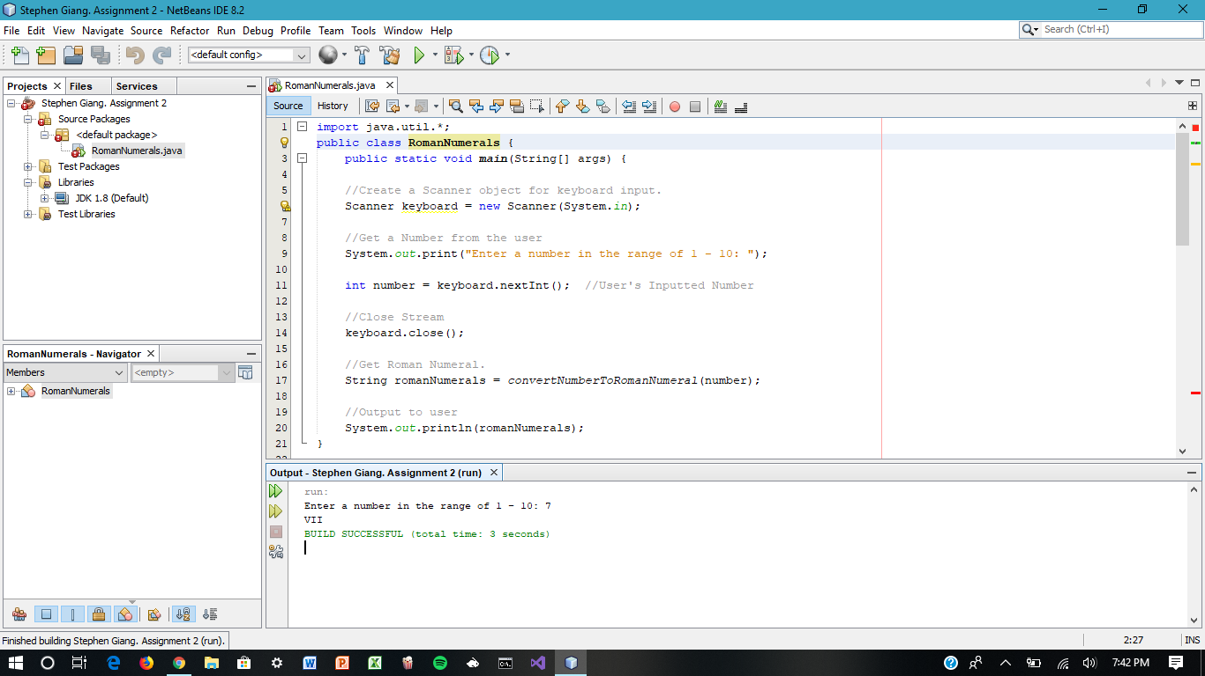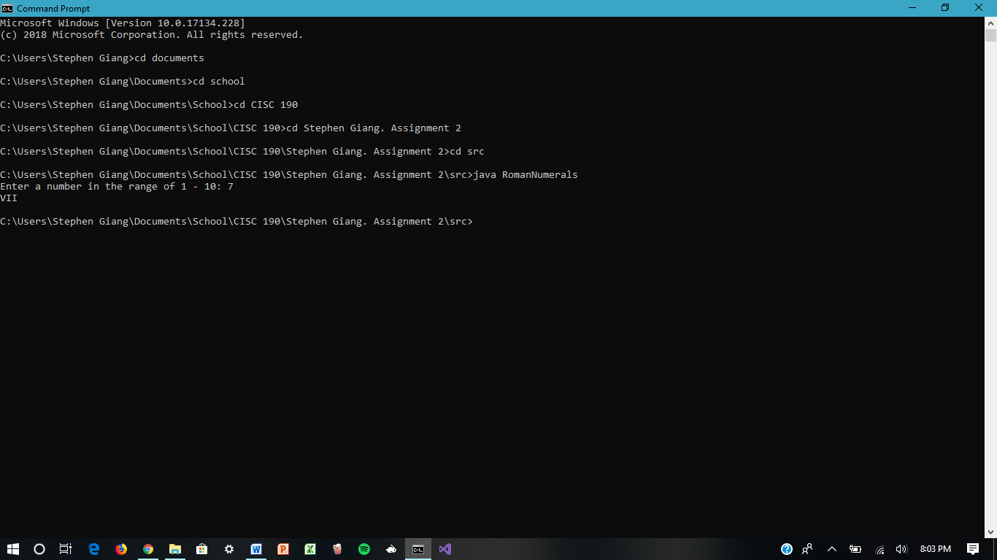

**Note:**

*If you can't Submit the Solution through the MPL's Workbench. Once you have filled in the required information, save the file to your flash drive / hard disk. Then, you can submit it to your instructor through your Blackboard Course for review and grading.*

**Appendix**

1. **Roman Numeral Converter**

Write a program that asks the user to enter a number within the range of 1 through 10. Use a switch statement to display the Roman numeral version of that number.

Input Validation: Do not accept a number less than 1 or greater than 10.

Prompts And Output Labels. Use the following prompt for input: "Enter a number in the range of 1 - 10: ". The output of the program should be just a Roman numeral, such as VII.

CLASS NAMES. Your program class should be called RomanNumerals

1. **Software Sales**

A software company sells a package that retails for $99. Quantity discounts are given

according to the following table:

Quantity Discount

10-19 20%

20-49 30%

50-99 40%

100 or more 50%

Write a program that asks the user to enter the number of packages purchased. The pro-

gram should then display the amount of the discount (if any) and the total amount of the

purchase after the discount. For instance, to calculate 20% of a value N, you can use

the formula: (20 / 100.0) * N (or 0.2 * N).

1. **Running the Race**

Write a program that asks for the names of three runners and the time, in minutes, it took

each of them to finish a race. The program should display the names of the runners in the

order that they finished.

1. **The Speed of Sound**

The speed of sound depends on the material the sound is passing through. Below is the approximate speed of sound (in feet per second) for air, water and steel:

* air: 1,100 feet per second
* water: 4,900 feet per second
* steel: 16,400 feet per second

Write a program class TheSpeedOfSound that asks the user to enter “air”, “water”, or “steel”, and the distance that a sound wave will travel in the medium. The program should then display the amount of time it will take.

You can calculate the amount of time it takes sound to travel in air with the following formula: time = distance/1,100

You can calculate the amount of time it takes sound to travel in watert with the following formula: time = distance/4,900

You can calculate the amount of time it takes sound to travel in steel with the following formula: time = distance/16,400

Prompts And Output. The program prompts for the medium with: "Enter one of the following: air, water, or steel: " and reads the medium. If the medium is not air, water or steel the program prints the message: "Sorry, you must enter air, water, or steel." an nothing else. Otherwise the program prompts for the distance with ("Enter the distance the sound wave will travel: " and reads it in and then prints "It will take x seconds." where x is the time calculated by your program.